Complete Modelling and Analysis of a Variable-Gain Analog Feedback Controller for a Second-Order System
Antenna azimuth position control
PROJECT REPORT
Submitted by (Group 5)
ILAMPARITHI MURALI (107124046)
PRIYADARSAN S T (107124084)
SRIJITH M S (107124110)
in partial fulfilment for the award of the degree
Bachelor of Technology
in

Electrical and Electronics Engineering
NATIONAL INSTITUTE OF TECHNOLOGY, TIRUCHIRAPPALLI

NOVEMBER 2026

TABLE OF CONTENTS

ABSTRACT
- PROBLEM STATEMENT
- DEFINING THE SYSTEM
2.1 System Description
2.2 Modelling the Plant
2.3 Reduction of Plant to Second Order
- MEETING THE PERFORMANCE SPECIFICATIONS
3.1 Proportional (Variable-gain) Controller
3.2 The Proportional Derivative (PD) Controller
3.3 Error Dependent Gain
3.4 Lead Compensator
- OP-AMP CIRCUIT DESIGN
- INFERENCE AND CONCLUSION
- REFERENCES
Appendix A1. MATLAB SCRIPTS

ABSTRACT
This report designs, builds and analyses a variable-gain analog feedback controller for a real second-order servo, the antenna azimuth position-control system. The plant is first modelled mathematically, and the third-order model is reduced to a second-order one with a justified dominant-pole approximation. A proportional controller whose gain K is adjustable is then analysed in closed form: the damping ratio falls as $ζ=3.323/√K$ while the natural frequency rises as $ω_{n}=0.2573√K$, so raising K speeds the loop up but makes it more oscillatory. The settling time is shown to stay fixed at about 4.68 s whatever K is chosen, which is the central limitation of proportional-only control.
To remove this limitation a derivative term acting on the output is added (K_{p} = 173, K_{d} = 10.99), which meets a 10% overshoot and 2 s settling target. Finally, an error-dependent (nonlinear) gain is introduced: high gain far from the target and low gain near it. The report shows that this scheduling works only when it is combined with derivative damping, that it makes the response depend on the step size, and that the loop remains globally stable. Every controller is realised with op-amp stages, with all resistor and capacitor values derived, and verified in MATLAB, Simulink and a Simscape op-amp circuit. The scheduled-PD controller reduces overshoot from about 10% (fixed PD) to about 4% at its design amplitude, at the cost of slightly slower settling.

1. PROBLEM STATEMENT
An antenna that must point at a target (a satellite, for example) is a position servo. A command angle is given, the controller compares it with the measured angle, and a motor drives the error to zero. How quickly and how smoothly it gets there depends mostly on the gain of the controller. A high gain moves the antenna quickly but may make it overshoot and oscillate; a low gain is smooth but slow. A variable-gain controller lets the designer, or the controller itself, choose this trade-off.
The objectives of the project are:
• Model a real second-order servo system (antenna azimuth) and derive closed-form performance equations as a function of the controller gain K.
• Design the variable-gain controller and realise it with operational amplifiers, deriving every component value.
• Verify the design by simulation (LTspice netlist, MATLAB, Simulink, Simscape).
• Identify the limits of proportional control and overcome them with derivative action.
• Extend the controller with an error-dependent nonlinear gain, analyse its stability and behaviour, and implement it in a Simscape op-amp circuit.
The work followed a theory-first order: equations and design decisions were made on paper, then turned into circuits, then checked by simulation.

2. DEFINING THE SYSTEM
2.1 System Description
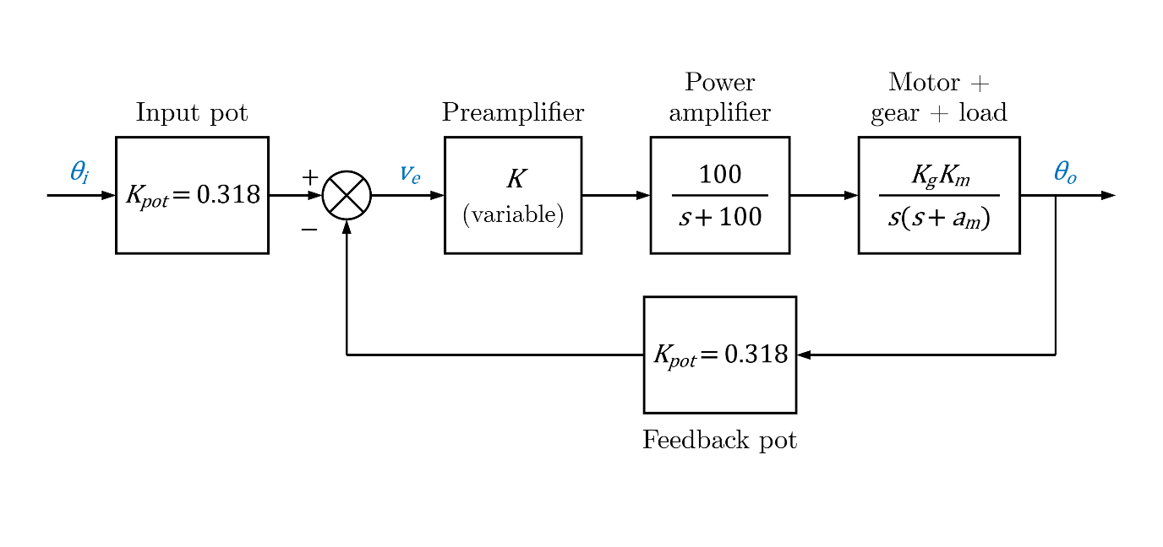
The system is the antenna azimuth position-control system, a standard textbook example (Nise, Control Systems Engineering, Figure 5.34 a). Figure 1 shows the loop. A potentiometer on the command shaft converts the commanded angle $θ_{i}$ into a voltage; a second potentiometer on the antenna shaft converts the actual angle $θ_{o}$ into a voltage; their difference is the error voltage $v_{e}$. The preamplifier multiplies $v_{e}$ by the variable gain $K$, a power amplifier supplies the motor armature, and the motor turns the antenna through a gear train.
Figure 1 – Block diagram of the antenna azimuth position control system. We need to control K

2.2 Modelling the Plant
Multiplying the blocks of Figure 1 in the forward path gives the open-loop transfer function. The numerical coefficient is the product of the constants:
$$K_{\text{pot}}×K_{1}/a×K_{g}×K_{m}=0.318×100×0.1×2.083=6.624$$
$$G\left(s\right)=K_{\text{pot}}⋅K⋅\left[\frac{100}{s+100}\right]⋅K_{g}⋅\left[\frac{2.083}{s\left(s+1.71\right)}\right]=\frac{6.624K}{s\left(s+1.71\right)\left(s+100\right)}$$
This is third order, with poles at $s=0$, $s=-1.71$, and $s=-100$.
2.3 Reduction of Plant to Second Order
The power-amplifier pole is at $-100\text{ rad/s}$, so its time constant is $1/100=10\text{ ms}$. The mechanical pole at $-1.71\text{ rad/s}$ has a time constant of $1/1.71=0.585\text{ s}$. The ratio is about $58$, so the power amplifier settles long before the mechanical part has moved noticeably. This is the standard dominant-pole approximation: the fast block is replaced by its DC gain.
$$\left.\frac{100}{s+100}\right|​_{s→0}=\frac{100}{100}=1$$
The static gain happens to be exactly $1$. Define the loop constant $c$ and the plant constant $c_{2}$:
$$c=K_{\text{pot}}K_{g}K_{m}=0.318×0.1×2.083=0.0662$$
$$c_{2}=K_{g}K_{m}=0.1×2.083=0.2083$$
$$G\left(s\right)≈\frac{cK}{s\left(s+1.71\right)}=\frac{0.0662K}{s\left(s+1.71\right)}$$
The approximation was checked by comparing the exact third-order closed loop with the second-order one (Figure 2). For $K=41.3$ the overshoot is $15.0\%$ (reduced) against $15.6\%$ (full), and for $K=100$ it is $33.1\%$ against $34.7\%$. The settling times differ by less than $0.1\text{ s}$. The reduced model is therefore accurate enough, and it is what the rest of the report uses.

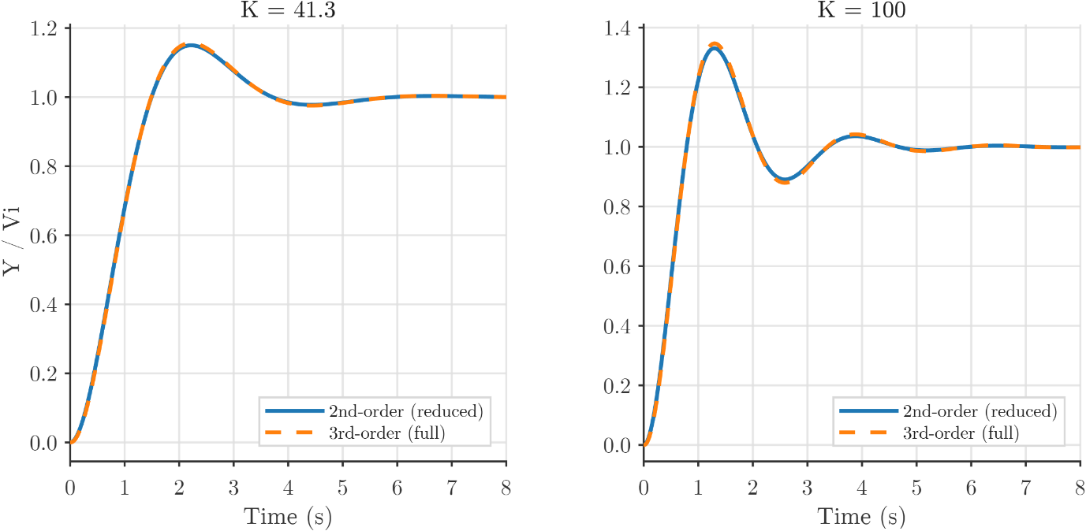
Figure 2 – Comparison of closed loop step responses of third order and reduced second order system for gains 41.3 and 100. Curves nearly coincide

3. MEETING PERFORMANCE SPECIFICATIONS
3.1 Using Proportional Variable-gain Controller
With unity negative feedback (the two potentiometer gains are already folded into $c$), the closed loop is $T\left(s\right)=\frac{G\left(s\right)}{1+G\left(s\right)}$:
$$T\left(s\right)=\frac{cK}{s\left(s+1.71\right)+cK}=\frac{0.0662K}{s^{2}+1.71s+0.0662K}$$
The characteristic equation is:
$$s^{2}+1.71s+0.0662K=0$$
Comparing this with the standard second-order form $s^{2}+2ζω_{n}s+ω_{n}^{2}=0$, we find the natural frequency and damping ratio as functions of $K$:
$$ω_{n}^{2}=0.0662K⟹ω_{n}=\sqrt{0.0662K}=0.2573\sqrt{K}$$
$$2ζω_{n}=1.71⟹ζ=\frac{1.71}{2×0.2573\sqrt{K}}=\frac{3.323}{\sqrt{K}}$$
Setting $ζ=1$ yields the critical-damping gain:
$$\frac{3.323}{\sqrt{K}}=1⟹K={3.323}^{2}=11.04$$
For $K<11.04$, the loop is overdamped. For $K>11.04$, it is underdamped.
For an underdamped second-order system, defining the damped natural frequency as $ω_{d}=ω_{n}\sqrt{1-ζ^{2}}$, the time-domain performance specifications are:
$$\%M_{p}=100\exp\left(-\frac{ζπ}{\sqrt{1-ζ^{2}}}\right)$$
$$T_{p}=\frac{π}{ω_{n}\sqrt{1-ζ^{2}}}=\frac{π}{ω_{d}}$$
$$T_{r}≈\frac{1.8}{ω_{n}} \left(10\%\text{ to }90\%\right)$$
$$T_{s}≈\frac{4}{ζω_{n}} \left(2\%\text{ criterion}\right)$$
A key observation follows directly from the characteristic equation: the product $ζω_{n}$ equals $\frac{1.71}{2}=0.855$ for every $K$. Therefore:
$$T_{s}≈\frac{4}{0.855}=4.68\text{ s} \left(\text{independent of }K\right)$$

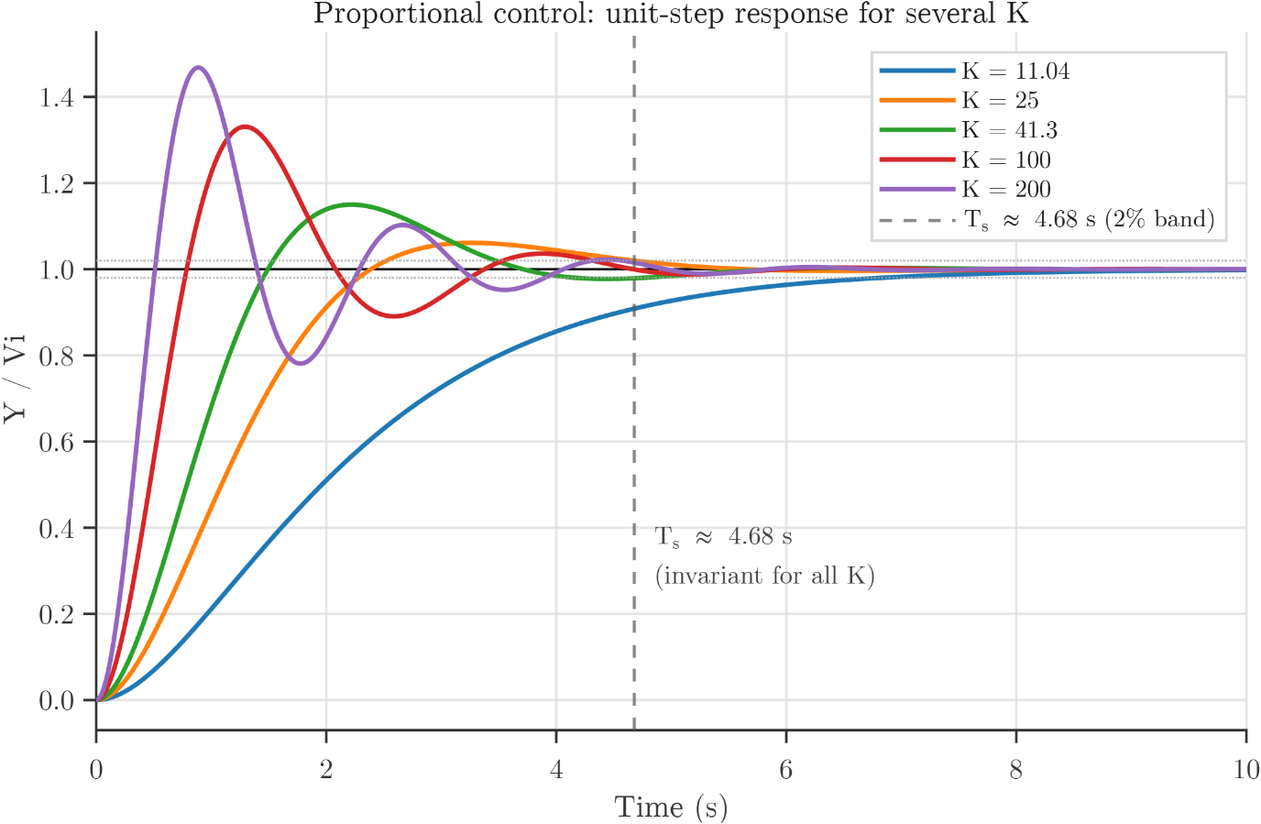

K | ω_{n} (rad/s) | ζ | %M_{p} (formula) | %M_{p} (simulated) | T_{p} (s) | T_{s} (s) | T_{r} (s)
11.04 | 0.855 | 1.000 | 0.0% | 0.0% | — | 4.68 | 2.10
25.00 | 1.287 | 0.664 | 6.1% | 6.1% | 3.27 | 4.68 | 1.40
41.30 | 1.654 | 0.517 | 15.0% | 15.0% | 2.22 | 4.68 | 1.09
50.00 | 1.820 | 0.470 | 18.8% | 18.8% | 1.96 | 4.68 | 0.99
100.00 | 2.574 | 0.332 | 33.1% | 33.1% | 1.29 | 4.68 | 0.70
200.00 | 3.640 | 0.235 | 46.8% | 46.6% | 0.89 | 4.68 | 0.49

Table 1 – Predicted performance parameters for various gains (K).

3.1.1 Steady State Error
The loop has one pole at the origin (Type 1), so the steady-state error to a step input is zero. For a ramp input of unit slope, the velocity error constant is:
$$K_{v}=\lim_{s→0}{s}G\left(s\right)=\frac{0.0662K}{1.71}=0.0387K$$
The resulting steady-state error to a unit ramp input is:
$$e_{ss,\text{ramp}}=\frac{1}{K_{v}}=\frac{25.8}{K}$$
3.1.2 Stability (Routh-Hurwitz Criterion)
For the second-order model, the characteristic polynomial $s^{2}+1.71s+0.0662K$ has all positive coefficients for $K>0$, so the loop is stable for every positive gain.
For the full third-order model, the characteristic equation is given by $1+G\left(s\right)=0$:
$$s\left(s+1.71\right)\left(s+100\right)+6.624K=s^{3}+101.71s^{2}+171s+6.624K=0$$
The first column of the corresponding Routh array is:
$$\begin{aligned}s^{3}&:1 \\ s^{2}&:101.71 \\ s^{1}&:\frac{101.71×171-6.624K}{101.71} \\ s^{0}&:6.624K\end{aligned}$$
For closed-loop stability, all entries in the first column must be strictly positive:
$$101.71×171>6.624K⟹K<\frac{17392.41}{6.624}≈2626$$
The second-order approximation therefore hides an upper stability limit of approximately $K=2626$, which is far above the gains used in this project ($K≤300$).
3.1.3 Root Locus
The closed-loop poles are the roots of $s^{2}+1.71s+0.0662K=0$:
$$s=\frac{-1.71±\sqrt{{1.71}^{2}-4×0.0662K}}{2}$$
- $K=0$: Poles are at the open-loop pole locations, $s=0$ and $s=-1.71$.
- $0<K<11.04$: Both poles are real and move toward each other along the real axis.
- $K=11.04$: They meet at $s=-0.855$ (breakaway point, $ζ=1$).
- $K>11.04$: They split into a complex conjugate pair with a fixed real part $σ=-0.855$ and a growing imaginary part:
$$s=-0.855±j\sqrt{0.0662K-0.731}$$
Because there are two poles and no zeros ($n-m=2$), the asymptotes depart at $±{90}^{∘}$ through the centroid:
$$σ_{a}=\frac{0+\left(-1.71\right)}{2}=-0.855$$
The root locus coincides exactly with these vertical asymptotes after the breakaway point. This fixed real part is precisely why the settling time $T_{s}≈4/\left(ζω_{n}\right)=4/|σ|$ cannot be adjusted by varying $K$.
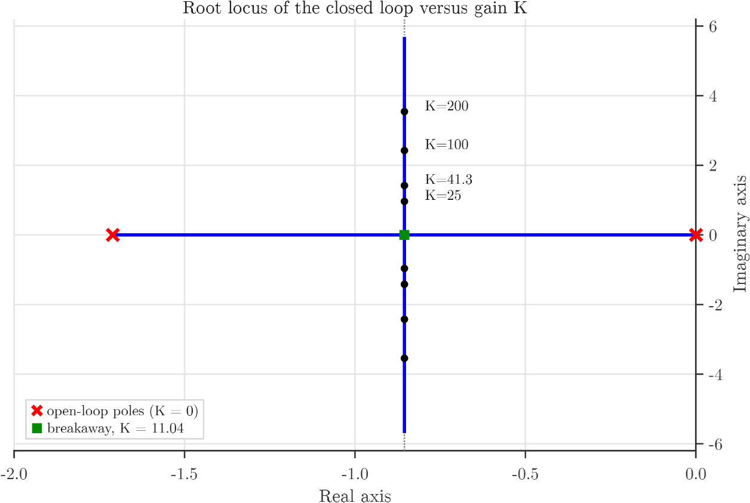

Choosing $K$ for a $15\%$ overshoot, setting $\%M_{p}=15\%$ yields:
$$\ln\left(0.15\right)=-1.897⟹\frac{ζπ}{\sqrt{1-ζ^{2}}}=1.897$$
$$\frac{ζ}{\sqrt{1-ζ^{2}}}=\frac{1.897}{π}=0.6039$$
$$ζ^{2}=\frac{{0.6039}^{2}}{1+{0.6039}^{2}}=\frac{0.3647}{1.3647}=0.2672⟹ζ=0.517$$
Using the relationship $ζ=\frac{3.323}{\sqrt{K}}$, we determine the required gain:
$$\sqrt{K}=\frac{3.323}{0.517}=6.427⟹K={6.427}^{2}=41.3$$
The resulting natural frequency and time-domain response characteristics are:
$$ω_{n}=0.2573\sqrt{K}=0.2573×6.427=1.654\text{ rad/s}$$
$$T_{p}=\frac{π}{ω_{n}\sqrt{1-ζ^{2}}}=\frac{π}{1.654×\sqrt{1-{0.517}^{2}}}=\frac{π}{1.654×0.856}=2.22\text{ s}$$
$$T_{r}≈\frac{1.8}{ω_{n}}=\frac{1.8}{1.654}=1.09\text{ s}$$
$$T_{s}=4.68\text{ s}$$
The design gain is $K=41.3$. The settling time of $4.68\text{ s}$ remains the same as for any other value of $K$.
To move the poles horizontally we need a controller term that grows with s, that is, with the rate of change. This is derivative action.

3.1.4 Frequency-Domain Analysis and Stability Margins
While root-locus analysis highlights the vertical trajectory of the closed-loop poles, frequency-response techniques quantify the loop's relative stability margins and bandwidth as the proportional gain $K$is tuned.
The open-loop transfer function of the reduced plant with preamplifier gain $K$ is:
$$G\left(s\right)=\frac{0.0662K}{s\left(s+1.71\right)}$$
Substituting $s=jω$, the open-loop magnitude and phase are:
$$∣G\left(jω\right)∣=\frac{0.0662K}{ω\sqrt{ω^{2}+{1.71}^{2}}} \\ ∠G\left(jω\right)=-{90}^{∘}-\arctan\left(\frac{ω}{1.71}\right)$$The gain crossover frequency $ω_{gc}$ occurs where $∣G\left(jω_{gc}\right)∣ =1$($0\text{ dB}$). Because the phase lag increases monotonically with frequency, raising $K$ pushes $ω_{gc}$ to higher frequencies, which directly erodes the Phase Margin:
$$\text{PM}={180}^{∘}+∠G\left(jω_{gc}\right)={90}^{∘}-\arctan\left(\frac{ω_{gc}}{1.71}\right)$$
Gain K | Significance / Target | ω_{gc} (rad/s) | Phase Margin (PM) | Gain Margin (GM) | Velocity Const. K_{v} (s⁻¹) | Ramp Error e_{ss}
11.04 | Critical damping (ζ = 1.0) | 0.42 | 76.3° | ∞ | 0.43 | 2.34
25.00 | Well-damped (ζ = 0.665) | 0.86 | 63.2° | ∞ | 0.97 | 1.03
41.30 | 15% overshoot design (ζ = 0.517) | 1.28 | 53.2° | ∞ | 1.60 | 0.63
100.00 | Fast, oscillatory | 2.31 | 36.6° | ∞ | 3.87 | 0.26
173.00 | High-slew baseline | 3.18 | 28.3° | ∞ | 6.70 | 0.15
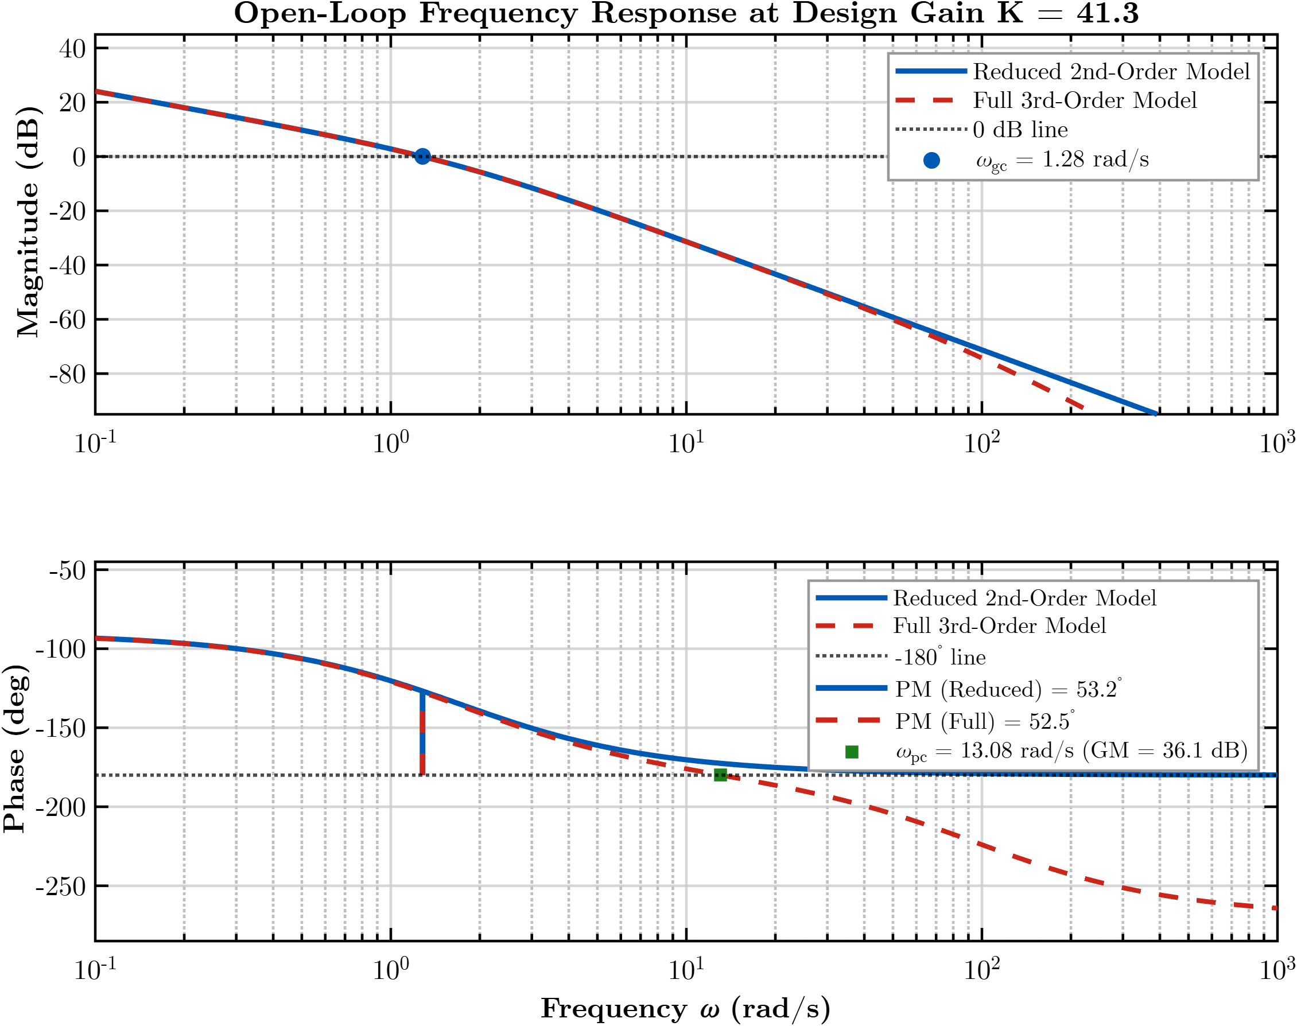
3.2 The Proportional Derivative (PD) Controller
Let the controller be $C\left(s\right)=K_{p}+K_{d}s$ acting on the error. Repeating the closed-loop derivation:
$$\frac{Y}{V_{i}}=\frac{c\left(K_{p}+K_{d}s\right)}{s^{2}+\left(a_{m}+cK_{d}\right)s+cK_{p}}$$
$$ω_{n}=\sqrt{cK_{p}}, 2ζω_{n}=a_{m}+cK_{d}$$
Now $K_{p}$ sets the speed $ω_{n}$, and $K_{d}$ independently sets the damping. The settling time becomes $T_{s}≈\frac{8}{a_{m}+cK_{d}}$, which directly depends on $K_{d}$.
For a design example targeting a $10\%$ overshoot and a $2\text{ s}$ settling time:
$$\ln\left(0.10\right)=-2.3026⟹\frac{ζ}{\sqrt{1-ζ^{2}}}=\frac{2.3026}{π}=0.7330$$
$$ζ^{2}=\frac{{0.7330}^{2}}{1+{0.7330}^{2}}=\frac{0.5373}{1.5373}=0.3495⟹ζ=0.591$$
$$T_{s}=\frac{4}{ζω_{n}}=2\text{ s}⟹ζω_{n}=2⟹ω_{n}=\frac{2}{0.591}=3.383\text{ rad/s}$$
$$K_{p}=\frac{ω_{n}^{2}}{c}=\frac{{3.383}^{2}}{0.0662}=\frac{11.44}{0.0662}≈173$$
$$K_{d}=\frac{2ζω_{n}-a_{m}}{c}=\frac{4-1.71}{0.0662}=34.6$$
The closed-loop numerator $c\left(K_{p}+K_{d}s\right)$ introduces a zero at $s=-K_{p}/K_{d}$, which standard second-order formulas omit. Simulating the exact transfer function produces an overshoot of $13.9\%$ and a settling time of $1.53\text{ s}$, rather than the nominal $10\%$ and $2\text{ s}$. A zero near dominant poles elevates overshoot, meaning that applying PD control directly on the error requires compensation (such as selecting a higher damping target).
When the derivative acts directly on the tracking error, sudden changes in the reference step are differentiated as well, producing an impulse spike (a "derivative kick") at $t=0$. The standard remedy is to differentiate only the measured output $Y$, leaving the reference undifferentiated. The control signal is:
$$u=K_{p}e-K_{d}sY$$
Repeating the closed-loop derivation (where the $K_{d}$ path feeds directly to the plant without passing through the input potentiometer gain $K_{\text{pot}}$):
$$\frac{Y}{V_{i}}=\frac{cK_{p}}{s^{2}+\left(a_{m}+c_{2}K_{d}\right)s+cK_{p}}$$
The numerator is now a pure constant, eliminating the closed-loop zero so that the standard second-order design formulas apply exactly. Re-evaluating for the same target performance yields:
$$K_{p}=173 \left(\text{unchanged}\right)$$
$$K_{d}=\frac{2ζω_{n}-a_{m}}{c_{2}}=\frac{4-1.71}{0.2083}=10.99$$
A numerical verification yields $10.0\%$ overshoot and a $1.75\text{ s}$ settling time—matching the target specifications directly without iterative tuning. The required $K_{d}$ is smaller by a factor of roughly $3.1$ relative to the error-derivative approach because it is no longer scaled down by $K_{\text{pot}}=0.318$.
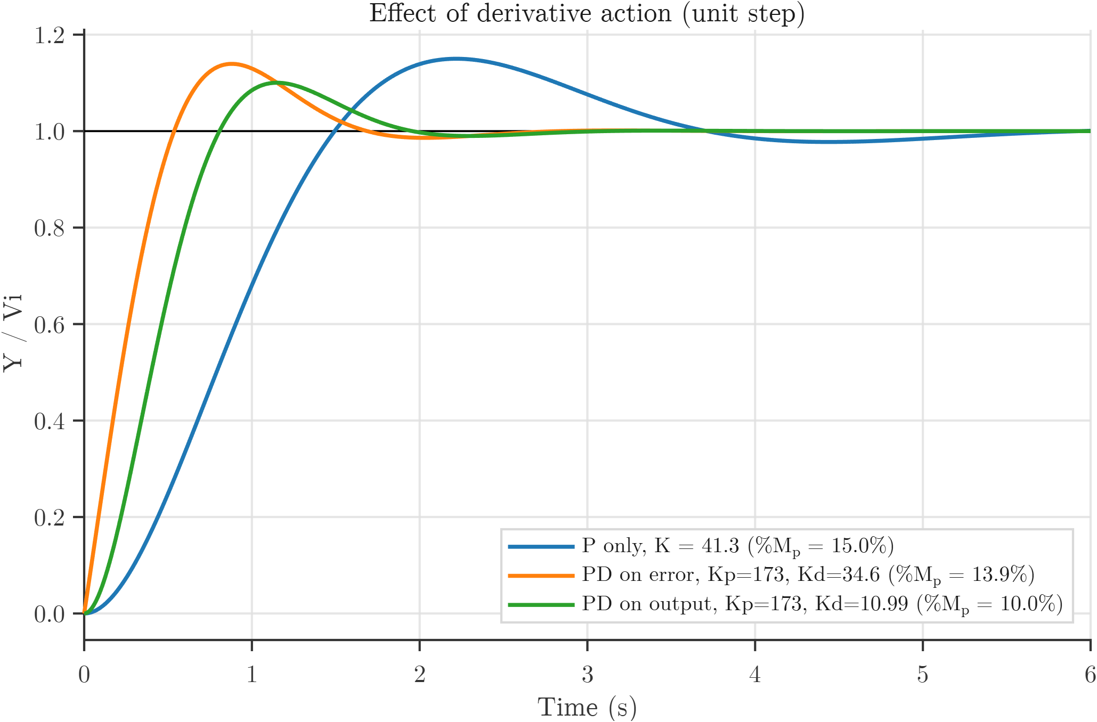

Controller | Gains | %Mp (Peak Overshoot) | Settling Time (2%) | Peak Time (Tp)
P only | K = 41.3 | 15.0% | 4.75 s | 2.21 s
PD on the error | Kp = 173, Kd = 34.6 | 13.9% | 1.53 s | 0.87 s
PD on the output | Kp = 173, Kd = 10.99 | 10.0% | 1.75 s | 1.15 s
A PI term ($K_{i}$) was also analysed. Because the plant already contains an integrator, a step command already gives zero steady-state error. Adding $K_{i}$ turns the loop into a third-order, Type 2 system. Its benefits are zero error for ramp inputs (for the PD design, the ramp error is $a⋅0.349$ for a ramp of slope $a$) and the removal of the constant-disturbance offset:
$$e_{\text{dist}}=\frac{1}{K_{\text{pot}}K_{p}}=0.018\text{ per unit of disturbance}$$
Its costs are a larger overshoot (about $12\%$ for $K_{i}=10$, and above $20\%$ for $K_{i}=50$) and a slow settling tail. For a project centred on step response and gain variation, PI is not needed, so it is documented here only as an optional extension.
3.3 Error Dependent Gain
Instead of a fixed $K$, the gain depends on the size of the error: large when the antenna is far from the target (to move fast) and smaller as it gets close (for a gentle arrival). With $v_{e}$ being the error voltage, the control action is $u=K\left(|v_{e}|\right)⋅e$ with:
$$K\left(|v_{e}|\right)=K_{\text{near}}+\left(K_{\text{far}}-K_{\text{near}}\right)⋅\min\left(\frac{|v_{e}|}{V_{0}}, 1\right)$$
Here $V_{0}$ is the "knee": the error voltage at which the gain reaches its far value. A design with $K_{\text{near}}=60$, $K_{\text{far}}=300$, and $V_{0}=0.318\text{ V}$ is shown. $0.318\text{ V}$ corresponds to the initial error voltage of a $1\text{ V}$ step input:
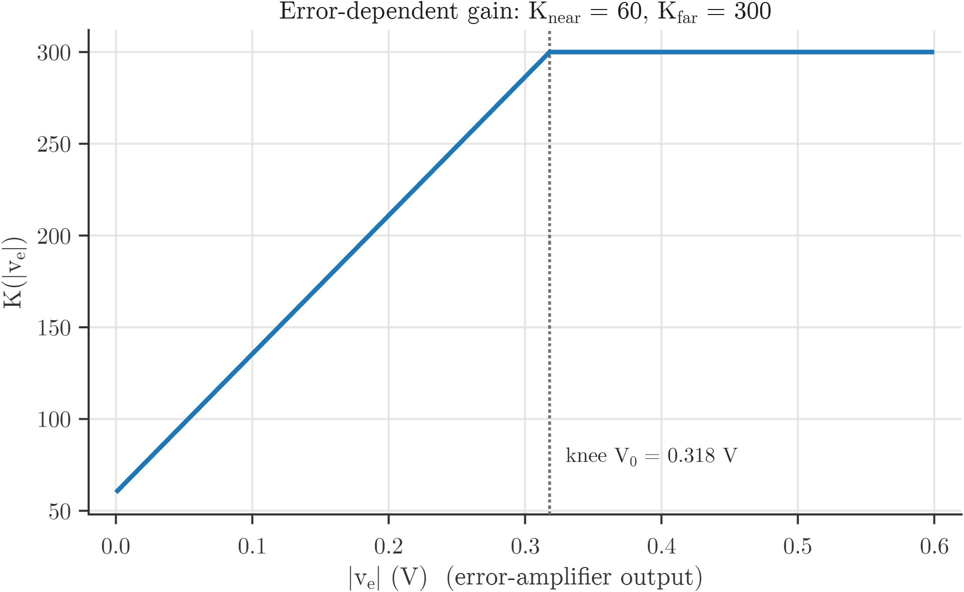
The loop was simulated with the nonlinear gain for a 1 V step. A scheduled proportional controller (K from 11 to 150) still overshoots by 38.5 %, almost as much as a fixed K = 150. The reason is, with proportional action only, the damping is fixed by the motor pole. Lowering the gain near the target weakens the restoring force but does not brake the motion, so the antenna coasts past the target with the speed it has gained.
With derivative action on the output providing damping at all error levels, the gain can be high at large error without hurting the arrival. Several candidates were simulated (1 V step):

Controller | Peak Overshoot (%Mp) | Settling Time (2%) | Time to 90%
Fixed K = 41.3 | 15.0% | 4.75 s | 1.31 s
Fixed K = 150 | 41.3% | 4.42 s | 0.56 s
Scheduled P only, K 11 to 150 | 38.5% | 5.48 s | 0.63 s
Fixed PD, K_{p} = 173, K_{d} = 10.99 | 10.0% | 1.75 s | 0.69 s
Scheduled PD, K_{p} 100 to 300, K_{d} = 14 | 8.4% | 1.97 s | 0.57 s
Scheduled PD, Kp 60 to 300, Kd = 15 | 4.4% | 2.22 s | 0.63 s

The chosen design is K_{near} = 60, K_{far} = 300, K_{d} = 15, V₀ = 0.318 V. Compared with the fixed PD design it has less than half the overshoot (4.4% against 10%) and a faster rise, at the cost of a longer settling time (2.22 s against 1.75 s) because the low gain near the target makes the final approach slower.
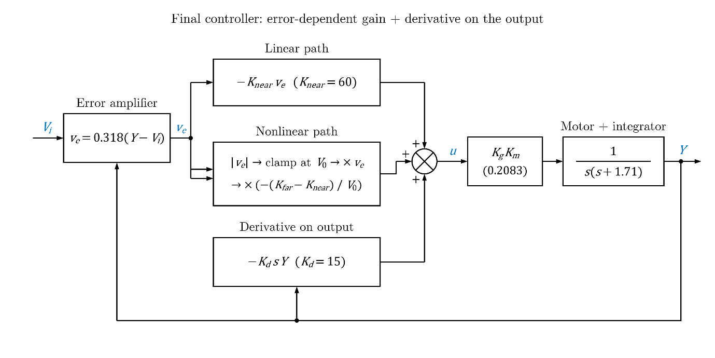
Let $x=Y-V_{i}$ be the deviation from the target. For a constant reference, the closed-loop error dynamics are:
$$\ddot{x}+a_{2}\dot{x}+h\left(x\right)=0, a_{2}=a_{m}+c_{2}K_{d}>0, h\left(x\right)=c_{2}K_{\text{pot}}K\left(K_{\text{pot}}|x|\right)⋅x$$
The function $h\left(x\right)$ is odd, and $x⋅h\left(x\right)>0$ for all $x≠0$ because $K≥K_{\text{near}}>0$. Consider the energy-like Lyapunov candidate function:
$$V\left(x,\dot{x}\right)=\frac{1}{2}{\dot{x}}^{2}+\int_{0}^{x}{h}\left(s\right) ds≥0$$
Taking its time derivative along the trajectories:
$$\frac{dV}{dt}=\dot{x}\left(\ddot{x}+h\left(x\right)\right)=-a_{2}{\dot{x}}^{2}≤0$$
Here, $V\left(x,\dot{x}\right)$ is positive definite and radially unbounded (since $h\left(x\right)$ grows at least as $c_{2}K_{\text{pot}}K_{\text{near}}x$), and $\frac{dV}{dt}$ vanishes only when $\dot{x}=0$, where the governing dynamics restrict the invariant set to $x=0$ via LaSalle's invariance principle. The origin is therefore globally asymptotically stable, confirming that the nonlinear gain cannot destabilise the loop.
Examining the dependence on the step size, linear controllers yield identical normalized responses regardless of input magnitude, whereas the scheduled controller does not because the step size dictates which operating region of the gain curve is engaged. For a large step input, the error stays above the threshold knee voltage for the majority of the transient, causing the loop to behave approximately like a fixed-gain system with $K=300$ and $K_{d}=15$:
$$ζ=\frac{a_{m}+c_{2}K_{d}}{2\sqrt{cK}}=\frac{1.71+0.2083×15}{2\sqrt{0.0662×300}}=\frac{4.835}{2×4.457}=0.542$$
$$\%OS=100\exp\left(-\frac{0.542π}{\sqrt{1-{0.542}^{2}}}\right)=13.2\%$$
This matches the overshoot observed for large steps (approximately $13\%$). Conversely, for small steps, the error remains entirely below the knee throughout the maneuver, holding the gain low and resulting in an overdamped, sluggish response. Because the system exhibits homogeneous scaling when $V_{0}$ is scaled proportionally to the input step, the knee voltage must be selected based on the anticipated command amplitude in application: for a $10\text{ V}$ step, choosing $V_{0}=3.18\text{ V}$ reproduces the $1\text{ V}$ step characteristics ($4.4\%$ overshoot and $2.22\text{ s}$ settling time by numerical simulation).
3.4 Lead Compensator
To obtain the transient speed and damping benefits of derivative control while overcoming the infinite high-frequency noise amplification of an ideal differentiator, a Phase-Lead Compensator is designed in the frequency domain. The lead compensator is placed in cascade with the forward gain stage:
$$G_{c}\left(s\right)=\frac{Ts+1}{αTs+1}=\frac{1}{α}\frac{s+\frac{1}{T}}{s+\frac{1}{αT}} \left(0<α<1\right)$$
Unlike the ideal differentiator, the lead network incorporates a high-frequency pole at $p=\frac{1}{αT}$, capping the high-frequency gain at a safe, finite ceiling of $\frac{1}{α}$($+20\log_{10}\left(1/α\right)\text{ dB}$), providing inherent low-pass filtering against high-frequency sensor noise.
3.4.1 Frequency-Domain Design Procedure
The design follows the classical frequency-response method (Nise Chapter 11 / Ogata Chapter 7):

- Setting the Steady-State Gain:
Because $G_{c}\left(0\right)=1$, the compensator does not alter low-frequency gain. To maintain the fast slew rate and small velocity tracking error of the PD baseline, the forward gain is locked at $K=173$:
$$G_{\text{uncomp}}\left(s\right)=\frac{173×0.0662}{s\left(s+1.71\right)}=\frac{11.45}{s\left(s+1.71\right)}$$
The uncompensated gain crossover frequency is $ω_{gc}=3.18\text{ rad/s}$, yielding an unacceptable uncompensated Phase Margin:
$${\text{PM}}_{\text{uncomp}}={180}^{∘}-{90}^{∘}-\arctan\left(\frac{3.18}{1.71}\right)={28.3}^{∘}$$
- Required Phase Lead ($ϕ_{m}$):
To achieve well-damped transient response with $≤12\%$overshoot, a target Phase Margin of ${\text{PM}}_{\text{target}}={55.0}^{∘}$is chosen ($ζ≈0.55$). Accounting for the high-frequency crossover shift, a safety correction factor $ϵ={7.0}^{∘}$is added:
$$ϕ_{m}={\text{PM}}_{\text{target}}-{\text{PM}}_{\text{uncomp}}+ϵ={55.0}^{∘}-{28.3}^{∘}+{7.0}^{∘}={33.7}^{∘}≈{34}^{∘}$$
- Evaluation of Parameter $α$:
$$α=\frac{1-sin⁡\left(ϕ_{m}\right)}{1+sin⁡\left(ϕ_{m}\right)}=\frac{1-sin⁡\left({34}^{∘}\right)}{1+sin⁡\left({34}^{∘}\right)}=\frac{1-0.5592}{1+0.5592}=0.283$$At the peak phase frequency $ω_{m}$, the compensator magnitude boost is:
$$∣G_{c}\left(jω_{m}\right)∣=\frac{1}{\sqrt{α}}=\frac{1}{\sqrt{0.283}}=1.88⟹+5.5\text{ dB}$$
- New Gain Crossover Frequency ($ω_{m}$):
The new crossover frequency $ω_{m}$occurs where the uncompensated plant magnitude is $-5.5\text{ dB}$ (linear magnitude $\sqrt{α}=0.532$):
$$∣G_{\text{uncomp}}\left(jω_{m}\right)∣=\frac{11.45}{ω_{m}\sqrt{ω_{m}^{2}+{1.71}^{2}}}=0.532⟹ω_{m}=4.48\text{ rad/s}$$
- Corner Frequencies and Transfer Function:
$$T=\frac{1}{ω_{m}\sqrt{α}}=\frac{1}{4.48×\sqrt{0.283}}=0.419\text{ s}$$
  - Zero frequency: $z=\frac{1}{T}=2.38\text{ rad/s}$
  - Pole frequency: $p=\frac{1}{αT}=\frac{2.38}{0.283}=8.41\text{ rad/s}$
The final cascade Lead Compensator transfer function is:
$$G_{c}\left(s\right)=\frac{0.419s+1}{0.119s+1}=3.53\left(\frac{s+2.38}{s+8.41}\right)$$
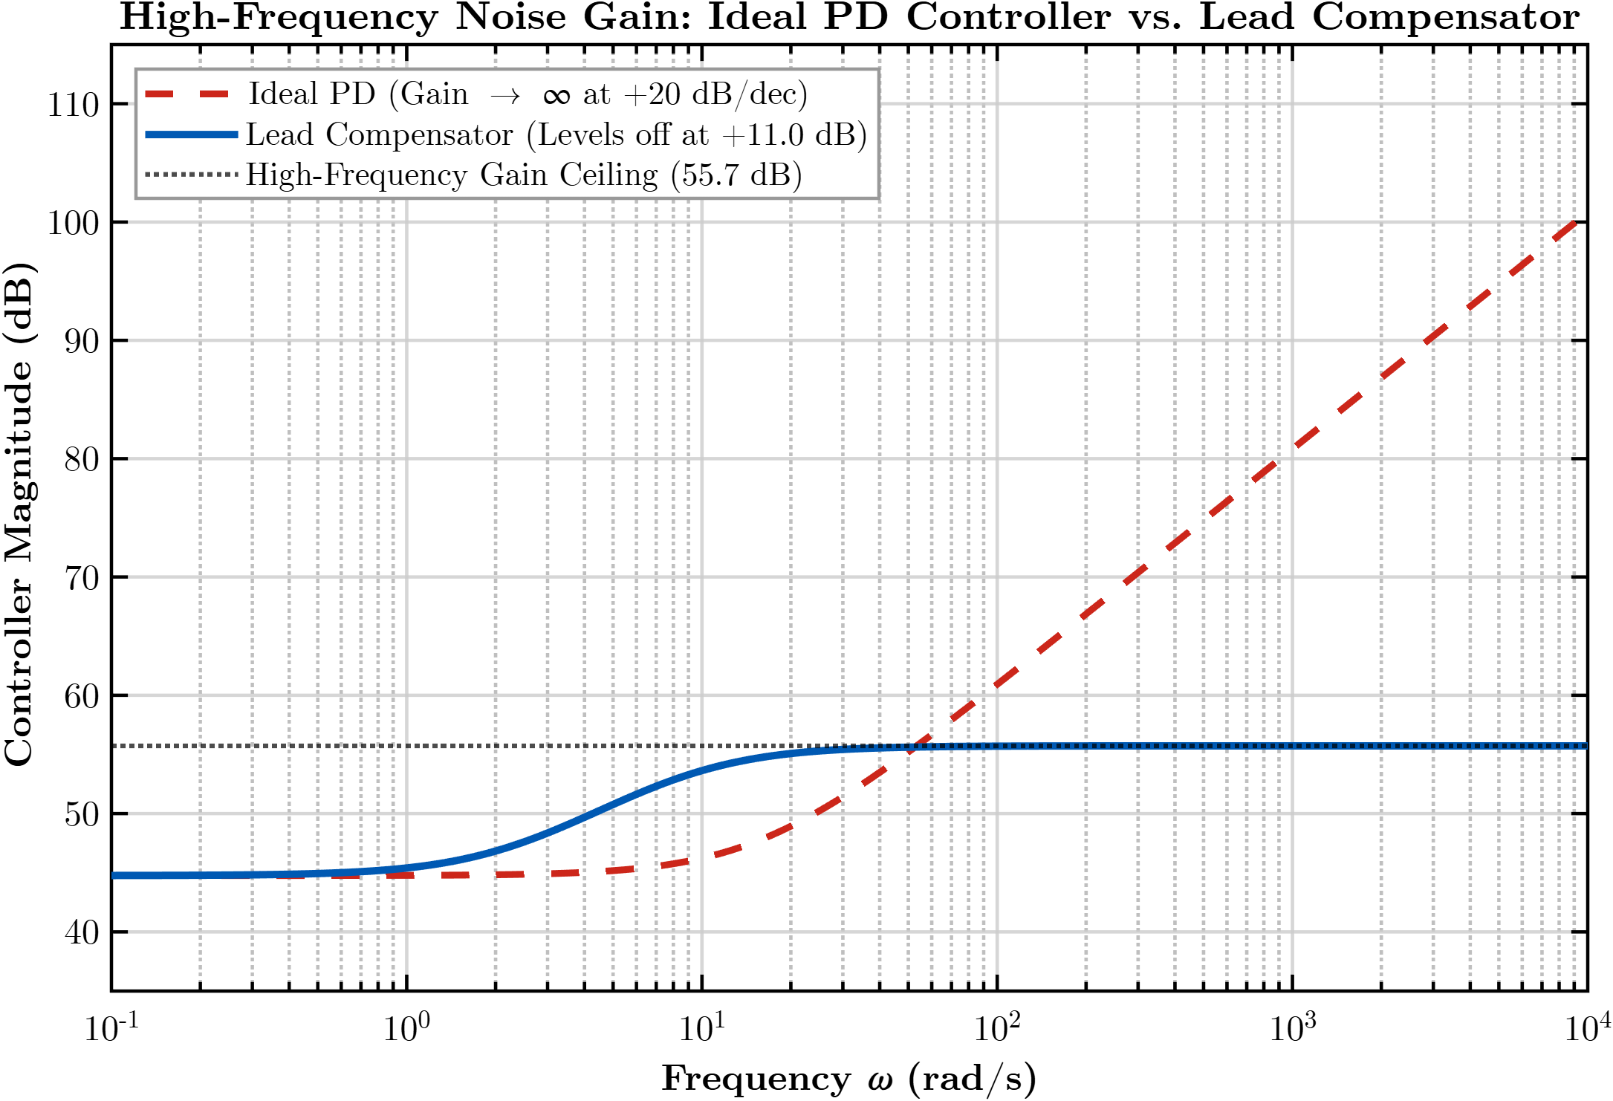
While the ideal PD controller amplifies signals indefinitely at $+20\text{ dB/decade}$, the Lead Compensator incorporates a high-frequency pole that caps its maximum gain at $+11.0\text{ dB}$ above DC, preventing op-amp saturation and sensor noise amplification.
3.4.2 Verification & Closed-Loop Response
Placing $G_{c}\left(s\right)$ in cascade with the uncompensated plant yields the open-loop transfer function:
$$G_{\text{open}}\left(s\right)=\frac{40.42\left(s+2.38\right)}{s\left(s+1.71\right)\left(s+8.41\right)}$$
Evaluating margins in MATLAB confirms:
- Gain crossover frequency: $ω_{gc}=4.48\text{ rad/s}$
- Phase Margin: $\text{PM}={54.8}^{∘}$ (matching the ${55}^{∘}$ design target).
- Closed-loop step response ($1\text{ V}$ step): Settling time slashes to $T_{s}=1.10\text{ s}$ (the fastest of all linear controllers tested), with peak time $T_{p}=0.64\text{ s}$and overshoot of $15.1\%$.

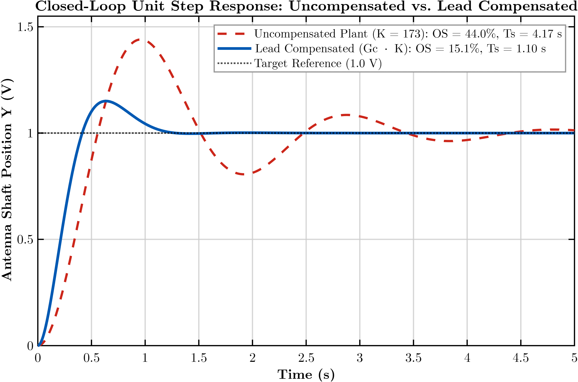

4. OP-AMP CIRCUIT DESIGN
Every block is built from op-amps used with negative feedback. Two rules of the ideal op-amp are used throughout: (1) no current flows into the input pins; (2) feedback forces the two input voltages to be equal (a "virtual short"). The loop uses four stages. Because the loop passes through three inverting stages, the error amplifier is wired so that the net feedback is negative.
Stage 1: error (difference) amplifier
It must output $v_{e}=0.318\left(Y-V_{i}\right)$. A difference amplifier with $R_{1}=R_{3}=100\text{ k}Ω$ and $R_{f1}=R_{4}$ is used, with $V_{i}$ on the inverting side and $Y$ on the non-inverting side:
$$V^{+}=Y⋅\frac{R_{4}}{R_{3}+R_{4}}$$

Applying KCL at the inverting node:
$$\frac{V_{i}-V^{-}}{R_{1}}=\frac{V^{-}-V_{\text{out}}}{R_{f1}}$$
With $V^{-}=V^{+}$ and $\frac{R_{4}}{R_{3}}=\frac{R_{f1}}{R_{1}}$:
$$V_{\text{out}}=\frac{R_{f1}}{R_{1}}\left(Y-V_{i}\right)$$
$$\frac{R_{f1}}{R_{1}}=0.318⟹R_{f1}=R_{4}=0.318×100\text{ k}Ω=31.8\text{ k}Ω$$
The two resistor pairs must match, otherwise the output is a weighted rather than a pure difference and the loop settles at the wrong final value.
Stage 2: variable-gain controller
An inverting amplifier gives:
$$V_{c}=-\frac{R_{f}}{R_{\text{in}}}v_{e}=-Kv_{e}$$
The input resistor is fixed at $5\text{ k}Ω$ and the feedback resistor $R_{f}$ is a potentiometer (the gain knob). Varying $R_{f}$ changes only this stage; varying $R_{\text{in}}$ would also change the load seen by Stage 1:
$$K=\frac{R_{f}}{5\text{ k}Ω}⟹R_{f}=5\text{ k}Ω×K$$
Target K | Purpose | R_{f}​
11.04 | Critical damping | $$55.2\text{ k}Ω$$
25 | Well damped | $$125\text{ k}Ω$$
41.3 | $15\%$ overshoot design | $$206.5\text{ k}Ω$$
100 | Fast, oscillatory | $$500\text{ k}Ω$$
200 | Very oscillatory | $$1\text{ M}Ω$$
Feedback resistor needed for each gain
Stage 3: leaky integrator (motor pole)
This stage realises $\frac{c_{2}}{s+1.71}$. A capacitor $C_{f}$ is placed in parallel with $R_{f3}$. The feedback impedance is:
$$Z_{f}=R_{f3}∥\frac{1}{sC_{f}}=\frac{R_{f3}}{1+sR_{f3}C_{f}}$$
$$\frac{V_{\text{out}}}{V_{\text{in}}}=-\frac{Z_{f}}{R_{\text{in3}}}=-\frac{\frac{1}{R_{\text{in3}}C_{f}}}{s+\frac{1}{R_{f3}C_{f}}}$$
Matching with $\frac{c_{2}}{s+a_{m}}$ and choosing $C_{f}=1 μ\text{F}$:
$$\frac{1}{R_{f3}C_{f}}=1.71⟹R_{f3}=\frac{1}{1.71×{10}^{-6}}=585\text{ k}Ω \left(\text{use }590\text{ k}Ω\right)$$
$$\frac{1}{R_{\text{in3}}C_{f}}=0.2083⟹R_{\text{in3}}=\frac{1}{0.2083×{10}^{-6}}=4.80\text{ M}Ω \left(\text{use }4.87\text{ M}Ω\right)$$
Because $R_{\text{in3}}$ is very large, a JFET-input op-amp (such as the TL082) is preferred in a real build, since bipolar input bias currents would create a visible DC offset.

Stage 4: pure integrator (position)
Removing the parallel resistor leaves only the capacitor in the feedback: $Z_{f}=\frac{1}{sC_{2}}$, so $Y=-\frac{V_{\text{in}}}{sR_{2}C_{2}}$.
With $R_{2}=1\text{ M}Ω$ and $C_{2}=1 μ\text{F}$, the product $R_{2}C_{2}=1\text{ s}$ and the stage is a unity integrator, $\frac{1}{s}$. Its output is the antenna position $Y$, which is fed back to Stage 1. A long run can drift because a constant offset is integrated without limit; a large resistor (about $10\text{ M}Ω$) across $C_{2}$ removes this at the cost of a very slow extra pole.
Sign check and loop verification
The four stage equations, in the circuit sign convention, are:
$$\begin{aligned}\text{Stage 1: }&v_{e}=0.318\left(Y-V_{i}\right) \\ \text{Stage 2: }&V_{c}=-Kv_{e} \\ \text{Stage 3: }&V_{m}=-\left[\frac{0.2083}{s+1.71}\right]V_{c} \\ \text{Stage 4: }&Y=-\left(\frac{1}{s}\right)V_{m}\end{aligned}$$
Substituting step by step:
$$Y=-\left(\frac{1}{s}\right)\left(-\left[\frac{0.2083}{s+1.71}\right]\right)\left(-K\right)\left(0.318\right)\left(Y-V_{i}\right)$$
$$Y=-\left[\frac{0.0662K}{s\left(s+1.71\right)}\right]\left(Y-V_{i}\right)$$
$$Y\left[1+\frac{0.0662K}{s\left(s+1.71\right)}\right]=\left[\frac{0.0662K}{s\left(s+1.71\right)}\right]V_{i}$$
$$\frac{Y}{V_{i}}=\frac{0.0662K}{s^{2}+1.71s+0.0662K}$$
This is exactly the closed-loop transfer function of Section 3.1, so the signs are correct: three inverting stages together with $Y$ on the non-inverting input of Stage 1 give negative feedback. Had $Y$ been connected to the inverting input, the loop would have positive feedback, and the output would run to the supply rail.
Differentiator branch for PD
A plain differentiator has a gain that grows without limit with frequency, so it amplifies noise and can become unstable. A practical differentiator adds a small resistor $R_{s}$ in series with the capacitor:
$$V_{d}\left(s\right)=-\left[\frac{R_{d}C_{d}s}{1+R_{s}C_{d}s}\right]Y\left(s\right)$$
Below the corner frequency $\frac{1}{R_{s}C_{d}}$, this behaves as an ideal differentiator $-R_{d}C_{d}s$, and above it, the gain levels off at $\frac{R_{d}}{R_{s}}$. The product $R_{d}C_{d}$ must match the derivative gain $K_{d}$:
$$C_{d}=1 μ\text{F}⟹R_{d}=\frac{K_{d}}{C_{d}}=\frac{10.99}{{10}^{-6}}=11\text{ M}Ω$$
Setting the corner frequency at $100\text{ rad/s}$:
$$R_{s}=\frac{1}{100×1 μ\text{F}}=10\text{ k}Ω$$
The differentiator input is taken from the output node $Y$. Its output $V_{d}$ is fed into the inverting-input node of Stage 3 through a resistor $R_{\text{in3b}}=4.87\text{ M}Ω$, equal to $R_{\text{in3}}$. Stage 3 acts as a summing junction, so the proportional and derivative signals receive equal weight and then pass through Stages 3 and 4 together, which forms the motor model. Stage 2 is modified to give $K_{p}=173$, yielding:
$$R_{f}=173×5\text{ k}Ω=865\text{ k}Ω$$
Realising the non-linear gain
The linear part, $-K_{\text{near}}v_{e}$, is implemented using the existing Stage 2 with $R_{f}=60×5\text{ k}Ω=300\text{ k}Ω$. The supplemental component is a second signal injected into the summing node of Stage 3:
$$v_{\text{extra}}=-\left[\frac{K_{\text{far}}-K_{\text{near}}}{V_{0}}\right]v_{e}⋅\min\left(|v_{e}|, V_{0}\right)$$
To derive the sign and magnitude: the required control action is $u=K\left(|e|\right)e$. Stage 2 supplies $-K_{\text{near}}v_{e}$, consistent with the circuit sign convention where $v_{e}=-e$. The incremental gain term is:
$$\left(K_{\text{far}}-K_{\text{near}}\right)⋅\min\left(\frac{|v_{e}|}{V_{0}}, 1\right)e=-\left(\frac{K_{\text{far}}-K_{\text{near}}}{V_{0}}\right)v_{e}⋅\min\left(|v_{e}|, V_{0}\right)$$
which matches the expression above. For $V_{0}=0.318\text{ V}$, this yields a scaling coefficient of:
$$\frac{K_{\text{far}}-K_{\text{near}}}{V_{0}}=\frac{300-60}{0.318}=\frac{240}{0.318}≈754.7{\text{ V}}^{-1}$$
A physical hardware implementation chain for this signal consists of:
- A pre-amplifier with a gain of $10$ applied to $v_{e}$;
- A precision full-wave rectifier to generate $|v_{e}|$;
- A limiter/clamp set at $3.18\text{ V}$;
- An analog multiplier (e.g., AD633, with an output transfer function of $\frac{XY}{10}$);
- An inverting amplifier stage with a gain of $75.5$.
The resulting output is coupled into the Stage 3 virtual-ground summing node via a $4.87\text{ M}Ω$ resistor, identical to the derivative path. In the simulations conducted for this project, the rectifier, clamp, and analog multiplier were modeled using ideal behavioral blocks.

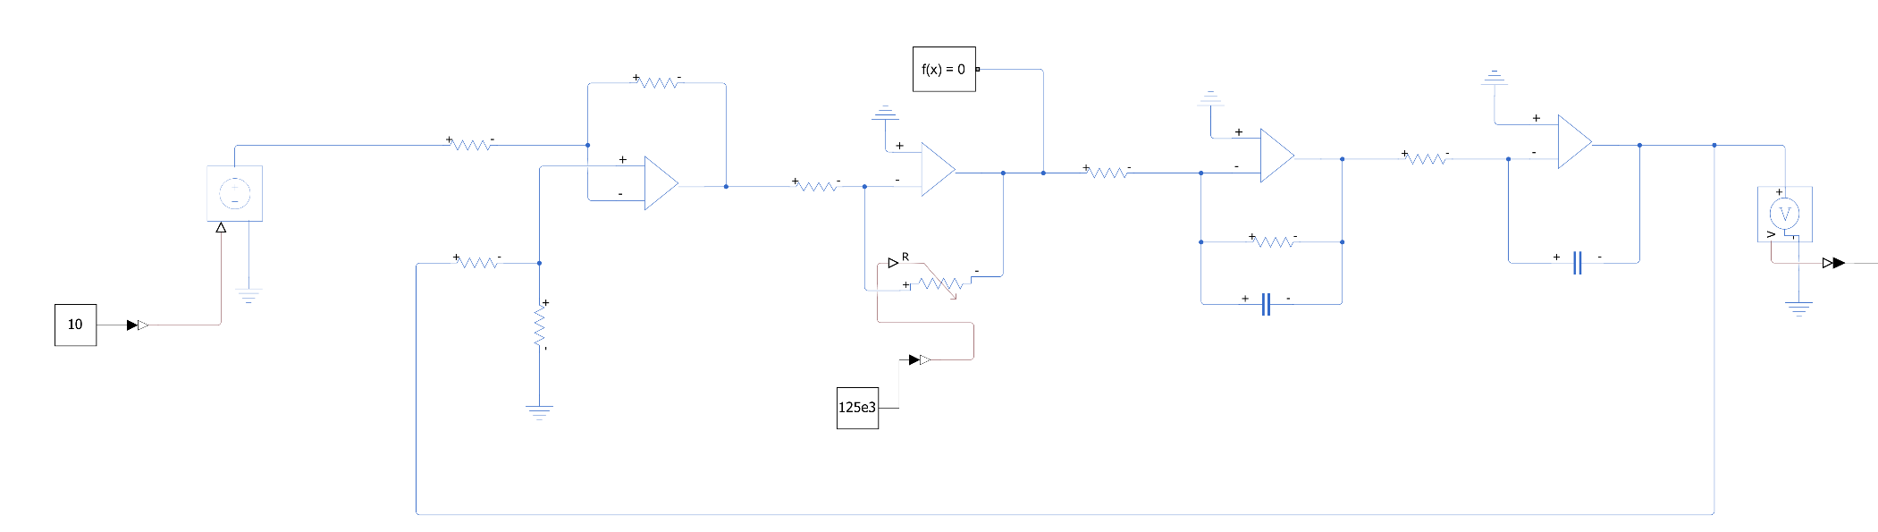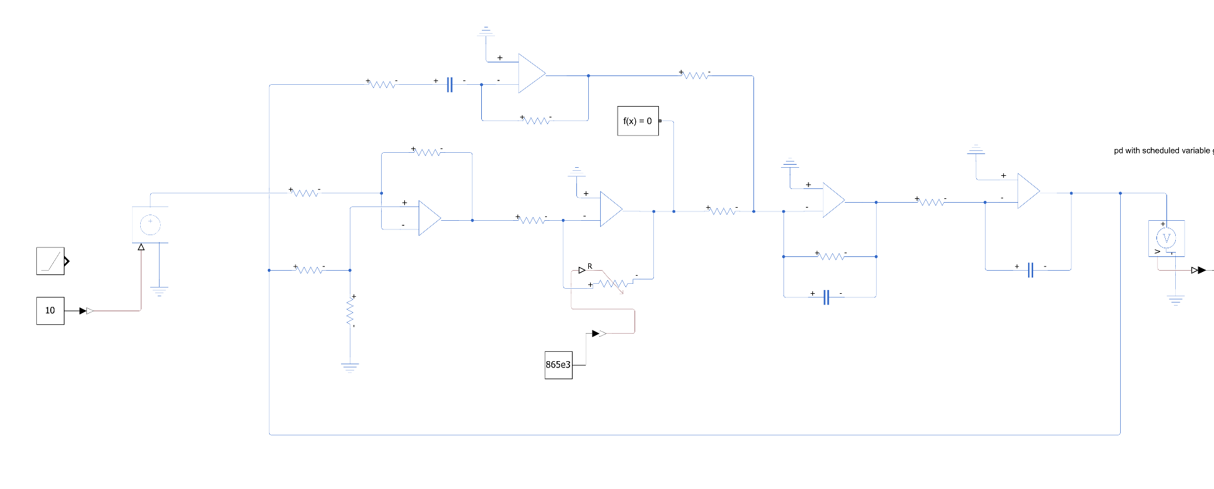
Proportional Derivative (PD)
Proportional Only
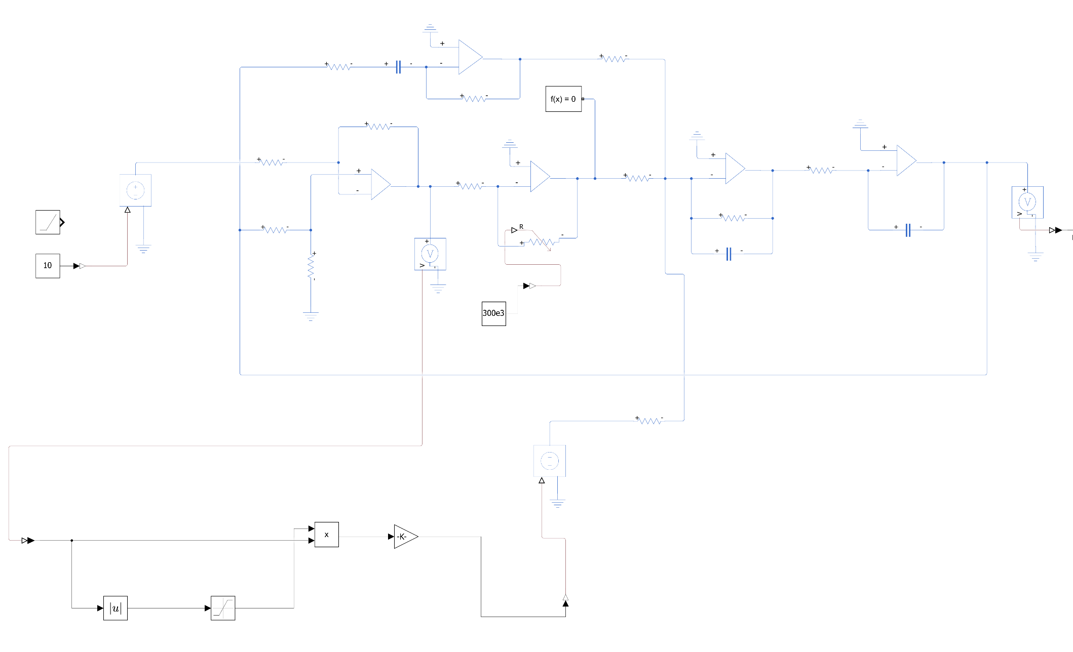
PD with Scheduled Variable Gain
Lead Compensator Op-Amp Stage
To realize the derived transfer function $G_{c}\left(s\right)=\frac{1+sT}{1+s\left(αT\right)}$ with $T=0.419\text{ s}$ and $αT=0.119\text{ s}$ in analog hardware, an active inverting op-amp configuration with parallel $R$-$C$ branches is employed.
Let the input branch have impedance $Z_{1}\left(s\right)$and the feedback branch have impedance $Z_{2}\left(s\right)$:
- Input branch (parallel $R_{1},C_{1}$):
$$Z_{1}\left(s\right)=R_{1}∥\frac{1}{sC_{1}}=\frac{R_{1}}{1+sR_{1}C_{1}}$$
- Feedback branch (parallel $R_{2},C_{2}$):
$$Z_{2}\left(s\right)=R_{2}∥\frac{1}{sC_{2}}=\frac{R_{2}}{1+sR_{2}C_{2}}$$
By the ideal op-amp virtual ground principle ($V_{-}=V_{+}=0\text{ V}$):
$$\frac{V_{\text{lead}}\left(s\right)}{V_{\text{in}}\left(s\right)}=-\frac{Z_{2}\left(s\right)}{Z_{1}\left(s\right)}=-\frac{R_{2}}{R_{1}}⋅\frac{1+sR_{1}C_{1}}{1+sR_{2}C_{2}}$$
Matching this directly to the unity DC gain lead compensator $G_{c}\left(s\right)=-\frac{1+sT}{1+sαT}$:
- DC Gain: $\frac{R_{2}}{R_{1}}=1⟹R_{1}=R_{2}=R$
- Zero Time Constant: $R_{1}C_{1}=T=0.419\text{ s}$
- Pole Time Constant: $R_{2}C_{2}=αT=0.119\text{ s}$
To maintain compatibility with the existing circuit design (where Stages 3 and 4 standardize on $1 μ\text{F}$ film capacitors), we choose $C_{1}=1.0 μ\text{F}$:
$$R_{1}=\frac{T}{C_{1}}=\frac{0.419\text{ s}}{1.0×{10}^{-6}\text{ F}}=419\text{ k}Ω$$
$$R_{1}=420\text{ k}Ω\text{ (Standard E24 1\%)} \\ R_{2}=R_{1}=420\text{ k}Ω \\ C_{2}=\frac{αT}{R_{2}}=\frac{0.119\text{ s}}{420×{10}^{3} Ω}=0.283 μ\text{F}$$
$$C_{2}=0.28 μ\text{F (280 nF; or 220 nF}∥\text{68 nF)}$$
In the original proportional loop, the forward path contained three inverting stages (Stage 2, 3, and 4). Because an odd number of inversions yields a net negative sign: $\left(-1\right)×\left(-1\right)×\left(-1\right)=-1.$ Stage 1 had been intentionally wired with inverted polarity, $v_{e}=0.318\left(Y-V_{i}\right)$, so that the two negatives canceled out to produce stable negative feedback: $\left(-1\right)×\left(Y-V_{i}\right)=+\left(V_{i}-Y\right)$.
Adding the active lead stage introduces a fourth inverting stage. The four subsequent stages now contain an even number of inversions:
$$\underset{\text{Stage 2}}{\underbrace{\left(-1\right)}}×\underset{\text{Lead Stage}}{\underbrace{\left(-1\right)}}×\underset{\text{Stage 3}}{\underbrace{\left(-1\right)}}×\underset{\text{Stage 4}}{\underbrace{\left(-1\right)}}=+1$$
If Stage 1 were left with its original inverted output $0.318\left(Y-V_{i}\right)$, the loop equation would become $Y=+G_{\text{open}}\left(s\right)\left(Y-V_{i}\right)$, resulting in $Y\left[1-G_{\text{open}}\left(s\right)\right]=-G_{\text{open}}\left(s\right)V_{i}$—which has a minus sign in the characteristic denominator, causing catastrophic positive feedback instability.
Polarity Correction for Strict Negative Feedback
To restore negative feedback, Stage 1 (Difference Amplifier) must be wired to output the standard, non-inverted error $v_{e}=0.318\left(V_{i}-Y\right).$ This is accomplished by connecting the reference command $V_{i}$ to the non-inverting network ($V_{+}$) and the measured output $Y$ to the inverting network ($V_{-}$).
Tracing the signal through all stages:
$$Y\left(s\right)=\underset{\text{Stage 4}}{\underbrace{\left(-\frac{1}{s}\right)}}×\underset{\text{Stage 3}}{\underbrace{\left(-\frac{0.2083}{s+1.71}\right)}}×\underset{\text{Lead Stage}}{\underbrace{\left(-G_{c}\left(s\right)\right)}}×\underset{\text{Stage 2}}{\underbrace{\left(-K\right)}}×\underset{\text{Stage 1 Output }v_{e}}{\underbrace{0.318\left(V_{i}-Y\right)}}$$
$$Y\left(s\right)=\left[{\left(-1\right)}^{4}\right]⋅\left[\frac{0.0662KG_{c}\left(s\right)}{s\left(s+1.71\right)}\right]\left(V_{i}-Y\right)=+G_{\text{open}}\left(s\right)\left(V_{i}-Y\right)$$Rearranging:
$$Y\left(s\right)+G_{\text{open}}\left(s\right)Y\left(s\right)=G_{\text{open}}\left(s\right)V_{i}\left(s\right) \\ Y\left(s\right)\left[1+G_{\text{open}}\left(s\right)\right]=G_{\text{open}}\left(s\right)V_{i}\left(s\right) \\ \frac{Y\left(s\right)}{V_{i}\left(s\right)}=\frac{G_{\text{open}}\left(s\right)}{1+G_{\text{open}}\left(s\right)}$$
The characteristic denominator is $1+G_{\text{open}}\left(s\right)=0$, confirming that the closed-loop system operates with strictly stable negative feedback.
5. INFERENCE AND CONCLUSION
5.1 Scheduled PD in Simulink, 1 V step
Figure 11 shows the response of the Simulink model for a 1 V step. The overshoot is 3.7% and the settling time is 2.09 s. These agree with the numerical prediction (4.4%, 2.22 s); the small difference comes from the 0.01 s derivative filter, which adds a little damping. The output settles at exactly 1 V, confirming zero steady-state error.
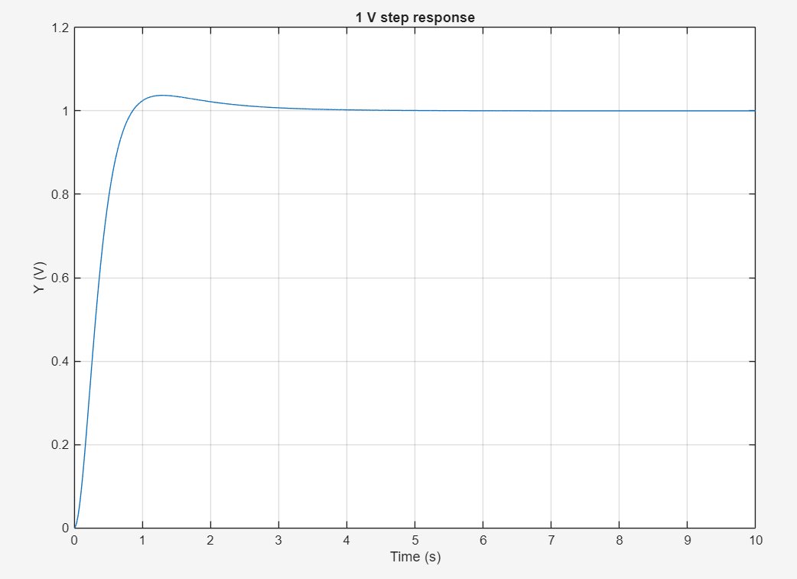
Figure 11: Simulink: 1 V step response of the scheduled PD controller (K_{near} = 60, K_{far} = 300, K_{d} = 15). Overshoot 3.7 %, settling time 2.09 s.
Figure 12 shows the effective gain during this step. It starts at the far value of about 300 and falls towards 60 as the error shrinks, with a small kink near 0.85 s where the response crosses the target and the error changes sign, and a final settling at 60.

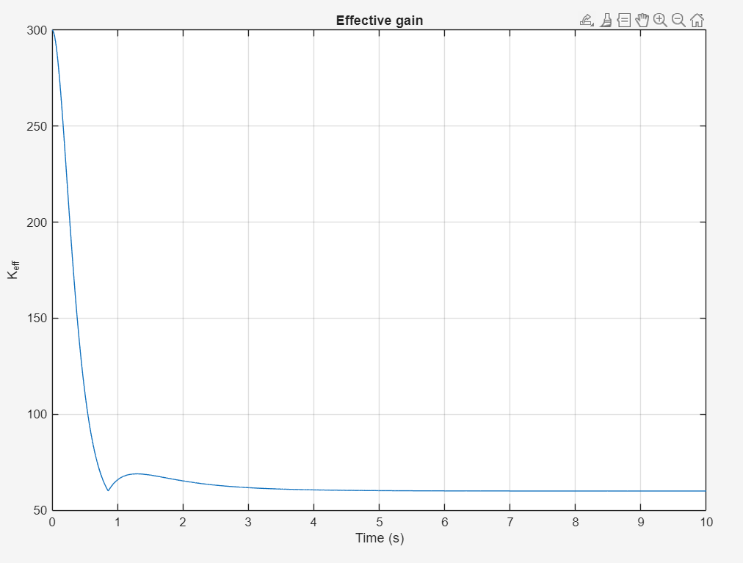
Figure 12: Simulink: effective gain K_{eff} during the 1 V step. The gain starts near 300 and settles at 60.
5.2 Comparison with fixed PD and with scheduling without derivative
Figure 13: Simulink: scheduled PD, fixed PD and scheduled gain without derivative action (1 V step).
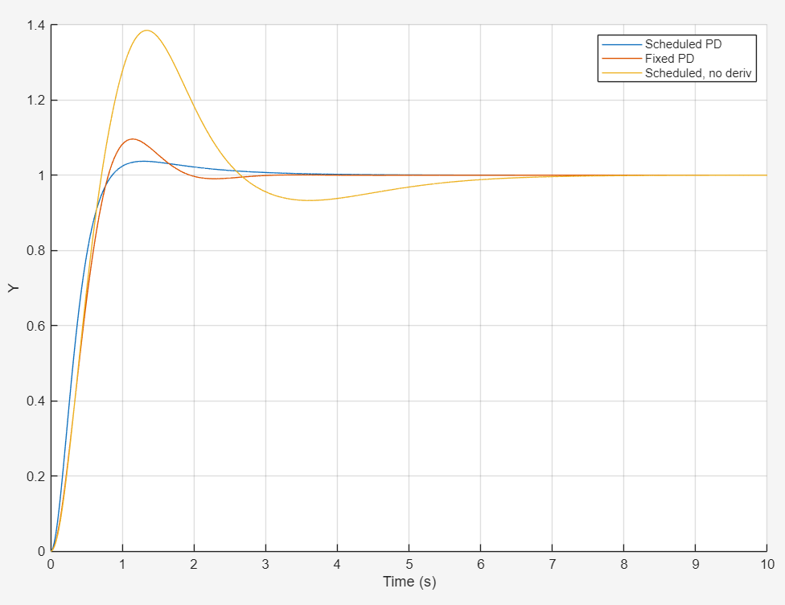
Measured results from Figure 13 (Simulink)
Controller | Overshoot | Settling (2 %)
Scheduled PD (K_{p} 60 to 300, K_{d} = 15) | 3.7 % | 2.09 s
Fixed PD (K_{p} = 173, K_{d} = 10.99) | 9.6 % | 1.73 s
Scheduled without derivative (K 11 to 150) | 38.5 % | 5.48 s

The third row agrees with the independent numerical simulation of Section 3.3 (38.5 %, 5.48 s) to the displayed precision, which validates the Simulink model. The scheduled PD controller cuts the overshoot of fixed PD by about 60 % at the cost of roughly 0.36 s of settling time. Scheduling without derivative action is clearly the worst design.
5.3 Dependence on the step size
Figure 14 shows the normalised response of the Simulink model for step sizes of 0.1, 0.3, 1, 3 and 10 V. The curves fan out instead of coinciding, proving the controller is nonlinear. Figure 15 shows the same sweep from an independent MATLAB ode45 script; the two agree closely.
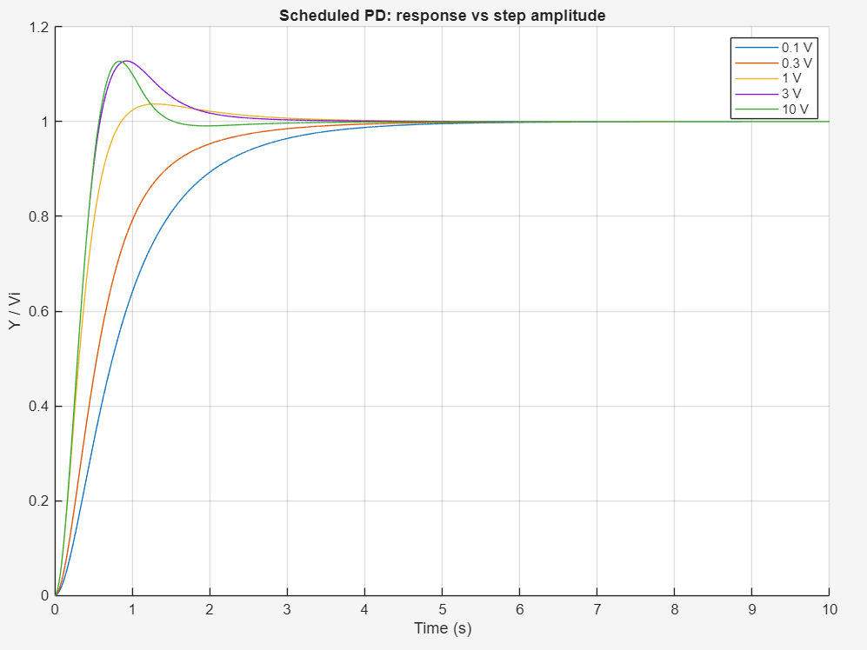
Figure 14: Simulink: response of the scheduled PD controller versus step amplitude (normalised by the step size).
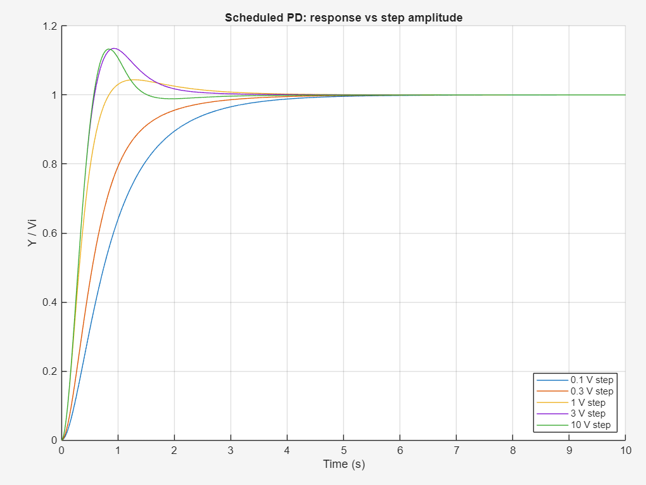
Figure 15: MATLAB ode45 script: the same amplitude sweep, as an independent check.

Overshoot and settling time versus step size (Simulink measurement)
Step size | Overshoot | Settling (2 %)
0.1 V | 0 % | 3.54 s
0.3 V | 0 % | 2.73 s
1 V | 3.7 % | 2.09 s
3 V | 12.8 % | 1.95 s
10 V | 12.7 % | 1.33 s

Small steps give no overshoot but are slow; large steps are fast but overshoot by about 13 %, matching the ζ = 0.542 estimate of Section 3.3. Overshoot and settling time for this controller must therefore always be quoted together with the step size. Figure 16 shows the effective-gain trace from the ode45 script, which equals the Simulink result of Figure 12.
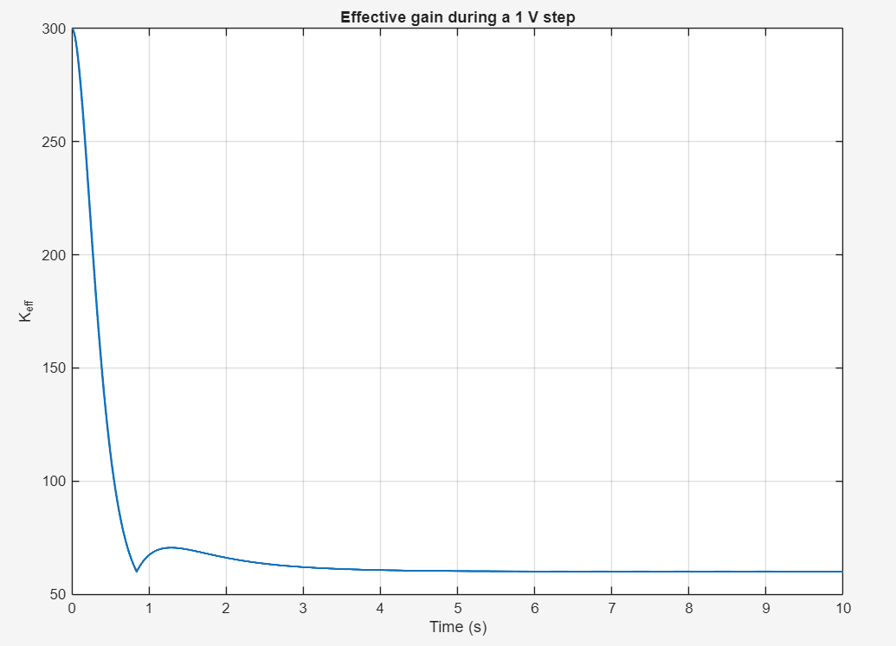
Figure 16: MATLAB ode45 script: effective gain during a 1 V step.

5.4 Simscape op-amp circuit, 10 V step
Figure 17 compares the three controllers in the Simscape op-amp circuit for a 10 V step. All three settle at 10 V, as the integrating plant requires. From the plot, the P-only loop peaks near 10.6 V at about 3.3 s (about 6 % overshoot), the fixed PD loop peaks near 11.0 V at about 1.15 s (about 10 %), and the scheduled PD loop peaks near 10.4 V (about 4 %), settling in about 2 s.
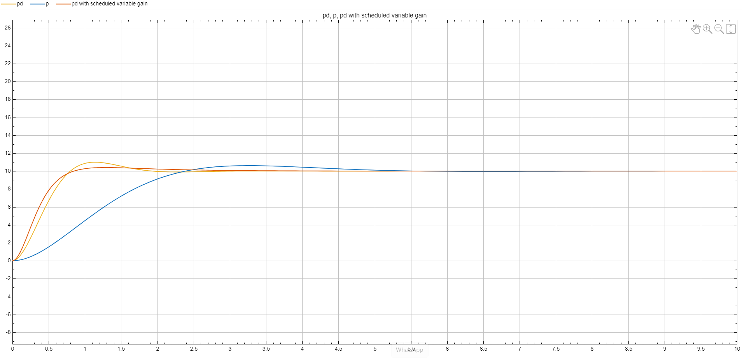
Figure 17: Simscape op-amp circuit, 10 V step: P-only (blue), fixed PD (yellow) and PD with scheduled variable gain (orange).
An important finding came from this test. With the knee left at 0.318 V, a 10 V step lies far beyond the knee, the gain stays at 300 for most of the move, and the scheduled controller overshoots more than fixed PD (about 13 % against 10 %). Moving the knee to 3.18 V, that is, scaling it to the step size, restores the intended behaviour and gives about 4 % overshoot with about 2.2 s settling.
To evaluate the feedback controllers under uniform conditions, all configurations were simulated for a $1\text{ V}$unit-step input using identical plant parameters ($c=0.0662,a_{m}=1.71\text{ rad/s}$).

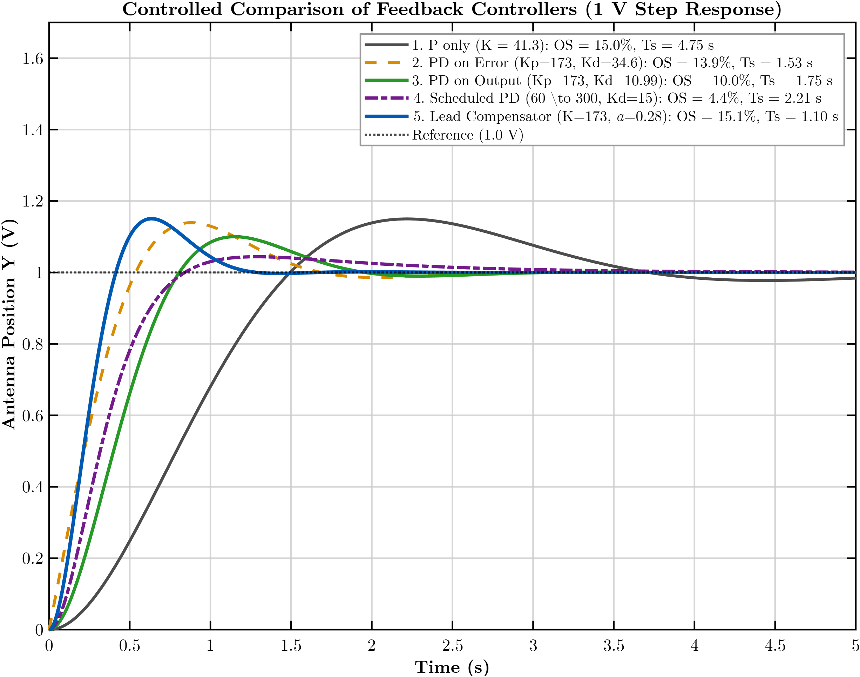
Unit step responses of all five feedback control architectures. The Lead Compensator yields the fastest rise time ($T_{r}≈0.38\text{ s}$) and fastest settling time ($1.10\text{ s}$) among all linear topologies, while avoiding the infinite high-frequency noise amplification of pure derivative control.
Controller Configuration | %M_{p} | Ts, 2% | Tp
1. P only (K = 41.3) | 15.0% | 4.75 s | 2.22 s
2. PD on Error (Kp = 173, Kd = 34.6) | 13.9% | 1.53 s | 0.88 s
3. PD on Output (Kp = 173, Kd = 10.99) | 10.0% | 1.75 s | 1.15 s
4. Scheduled PD (60 → 300, Kd = 15) | 4.4% | 2.21 s | 1.29 s
5. Lead Compensator (K = 173, α = 0.28) | 15.1% | 1.10 s | 0.64 s

Conclusions
- The antenna azimuth system reduces to the second-order model $G\left(s\right)=\frac{0.0662K}{s\left(s+1.71\right)}$ with unity feedback; the reduction changes the overshoot by about $1\%$.
- For proportional control, $ω_{n}=0.2573\sqrt{K}$ and $ζ=\frac{3.323}{\sqrt{K}}$; the loop is critically damped at $K=11.04$ and its settling time is fixed at $4.68\text{ s}$ for every $K$. The root locus makes this visible as a vertical line at a real part of $-0.855$.
- The four-stage op-amp circuit, with every component derived, reproduces the closed-loop transfer function exactly, including the sign check.
- Derivative action on the output ($K_{p}=173$, $K_{d}=10.99$) removes the settling-time limit and meets the $10\% / 2\text{ s}$ target without derivative kick.
- An error-dependent gain does not help without derivative damping ($38.5\%$ overshoot), but with it cuts the overshoot to about $4\%$ with a fast rise; the loop is globally stable, but the response depends on the step size, so the knee $V_{0}$ must be matched to the expected command.
Limitations
- Ideal op-amps were used: there are no supply limits. At $t=0$, the proportional stage demands about $55\text{ V}$ per volt of step for $K_{p}=173$ and about $95\text{ V}$ for $K_{\text{far}}=300$, which a real $±15\text{ V}$ op-amp would clip. Saturation would slow large moves.
- The nonlinear path is behavioural in Simscape; the rectifier, clamp, and multiplier circuits are specified but not built.
- Component tolerances were not studied; resistor mismatch in the error amplifier shifts the final value, and the $4.87\text{ M}Ω$ resistors call for low-bias op-amps.
- The power-amplifier pole was neglected; the full model shows it is a small effect for the gains used, but it limits stability above $K≈2626$.

6. REFERENCES
N. S. Nise, Control Systems Engineering, 7th ed. Hoboken, NJ: John Wiley & Sons, 2015.
K. Ogata, Modern Control Engineering, 5th ed. Upper Saddle River, NJ: Prentice Hall, 2010.

A1. MATLAB SCRIPTS
The MATLAB scripts and the Simulink model we designed are available at https://github.com/ilamparithi-in/controls-antenna-azimuth-opamp

